Basic Linux Commands Assignment

- Use the pwd command to display your current working directory. Share the output.

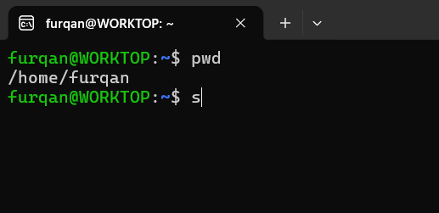

- Use the ls, ls -a, ls -l, and ls -R commands to list files and directories in different ways. Share the outputs and explain the difference between these commands.

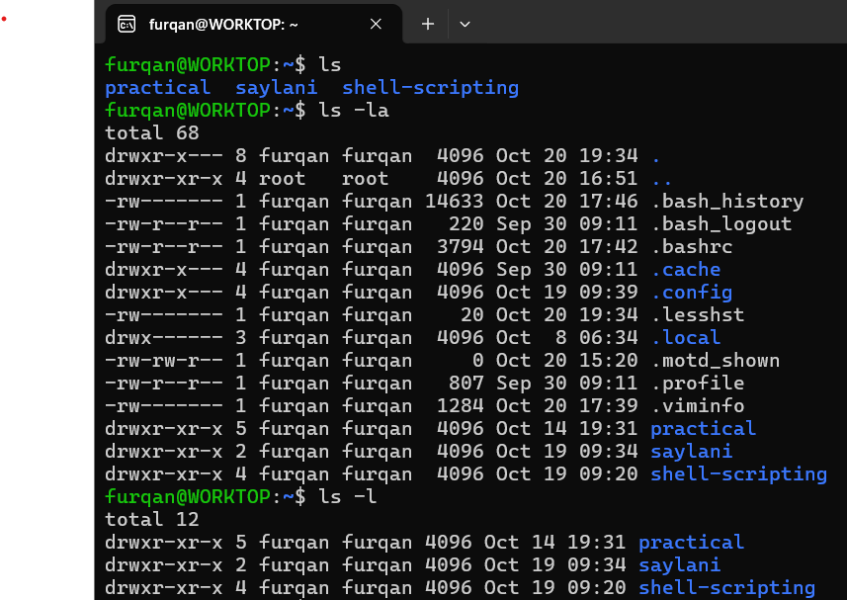

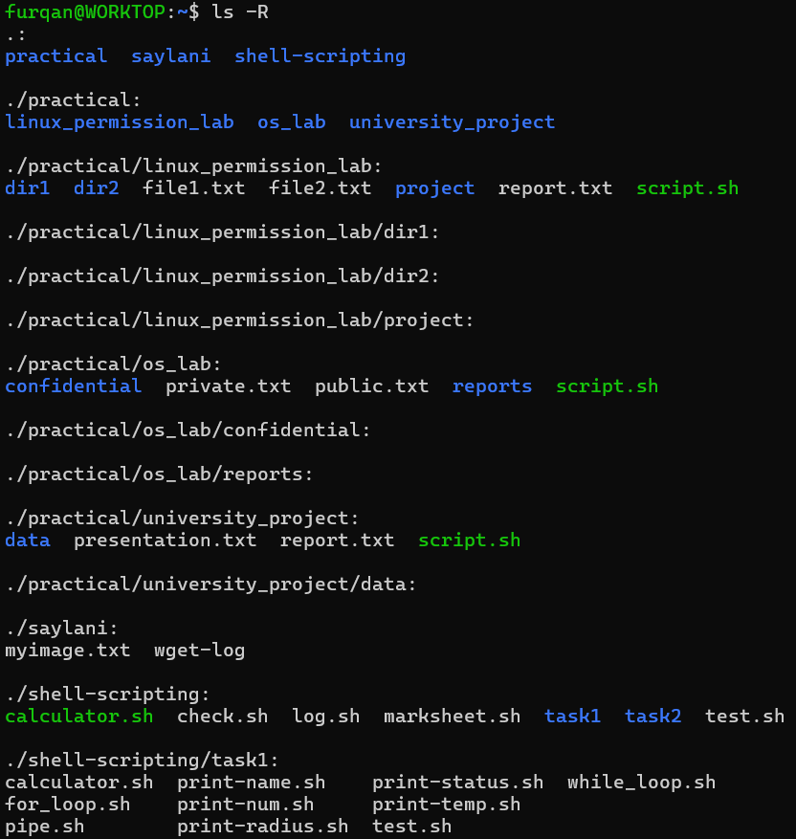
- Use the mkdir command to create a directory named linux_assignment. Then use ls to verify that it was created.
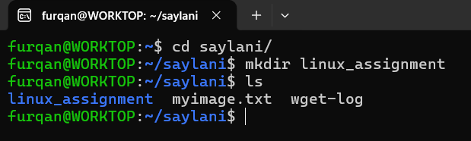

- Use the cd command to enter the linux_assignment directory. Use pwd to confirm your current location.

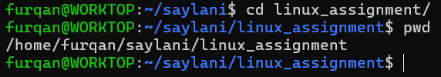

- Create three empty files named file1.txt, file2.txt, and file3.txt using the touch command. Use ls -l to verify their creation.

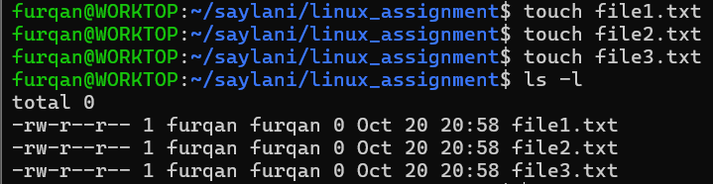

- Use the echo command to write a message into file1.txt. Then use the cat command to display the contents of the file.

- Use the nano command to create or edit file2.txt. Write at least three lines of text, save the file, and display its contents using cat.

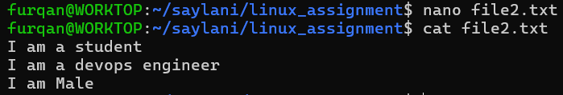

- Create a directory named backup inside linux_assignment. Use the mv command to move file3.txt into the backup directory. Verify the result using ls.

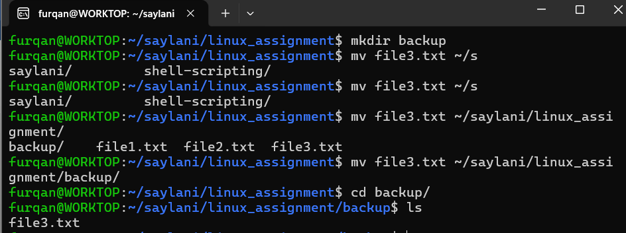

9. Use the cp command only if you have covered it in class; otherwise, skip this question. Copy file1.txt to a new file named file1_copy.txt and verify that both files exist.

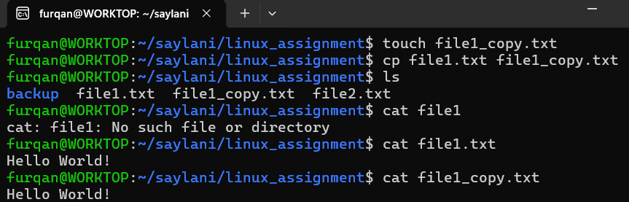

- Use the rm command to delete file1_copy.txt. Use ls to confirm that the file has been removed.

11. Use the cd .., cd ~, and cd / commands one by one. After each command, use pwd to show which directory you are in.

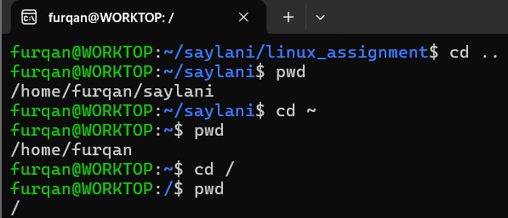

12. Use the man command to open the manual for ls. Find the description of the -a option. Share what it does.

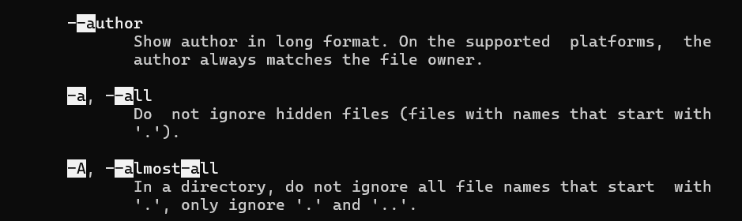

13. Use the history command to display your previously executed commands. Share at least 10 commands from your terminal history.

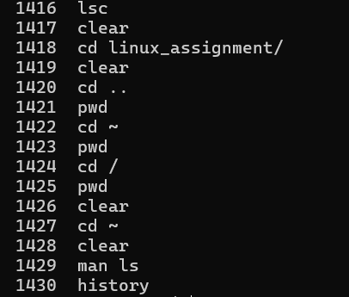

14. Use the which, type, and whatis commands on ls, cd, and pwd. Record the outputs and identify which commands are shell built-ins and which are external programs, where applicable.

